ECE 4429a – Advanced Digital Signal Processing
Fall 2020
MATLAB experiments on Correlation & Spectrum Analysis
October 14, 2020
Chandan Chandel -250914472
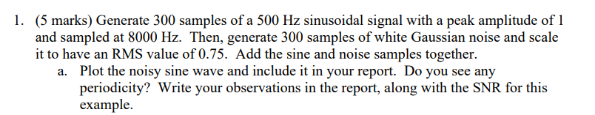
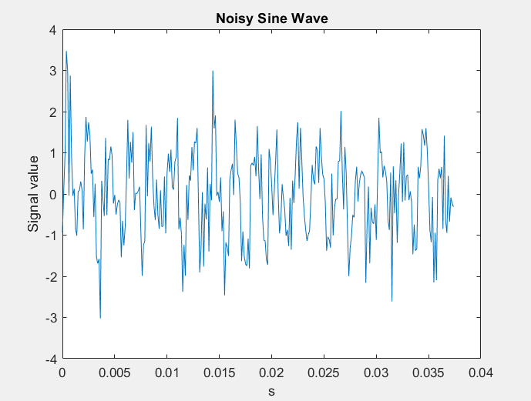
There may be some periodicity due to the original signal however the noise is obscuring it from view, SNR was calculated to be -0.5260.

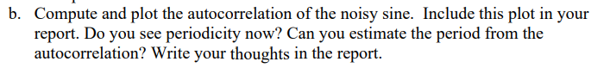
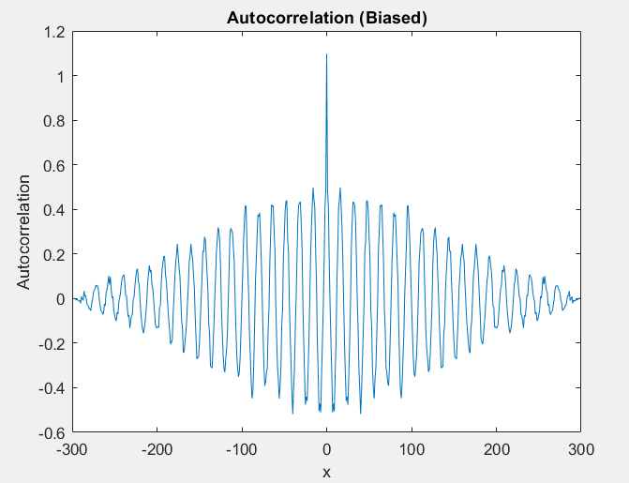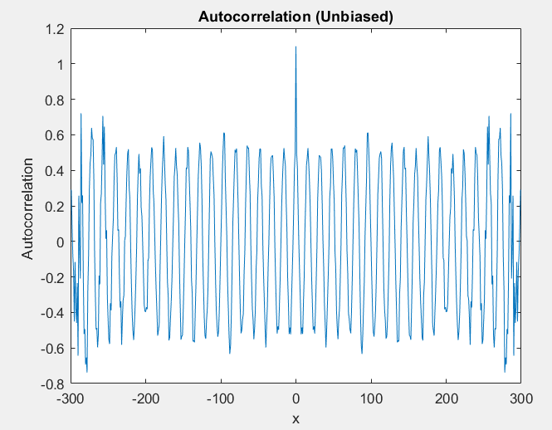

I used both biased and unbiased methods of autocorrelation, I can see periodicity clearly now. They are identical between the two graphs. The period can be determined by finding the peaks and dividing the sampling frequency by the distance between any two peaks. It matches the frequency of the original signal at 500 Hz.
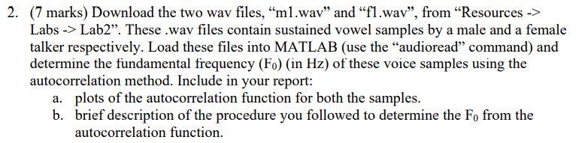
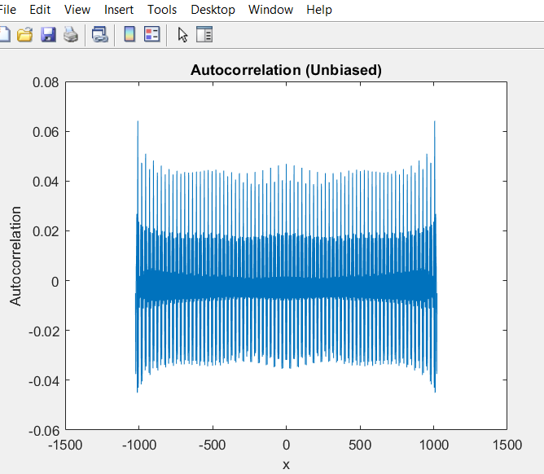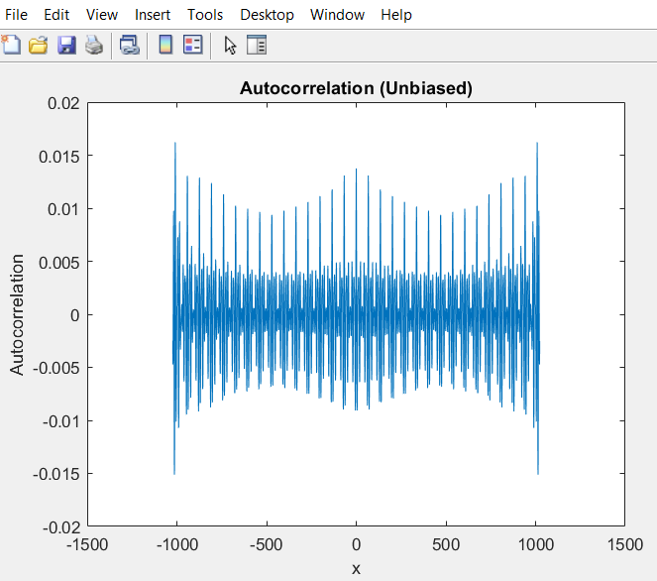
In the time domain the fundament frequency can be determined by finding the distance between peaks and dividing by the sampling frequency. The fundamental frequency of f1 was found to be 307.7Hz and m1 was 119.4 Hz.

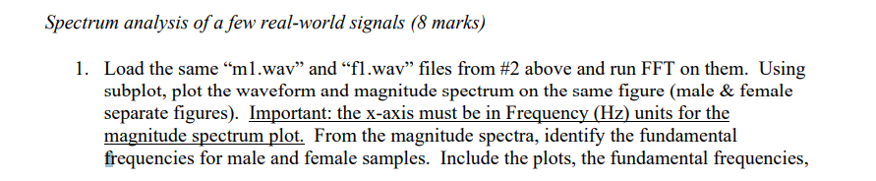

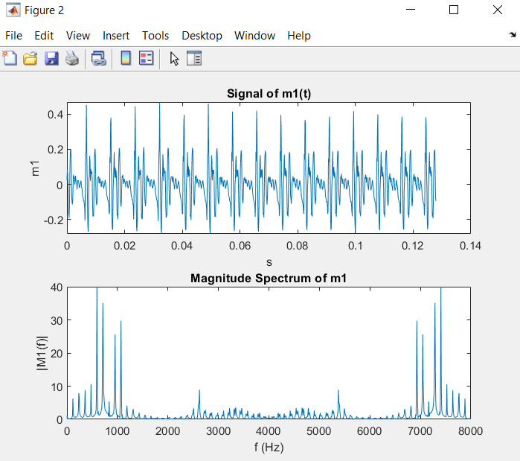
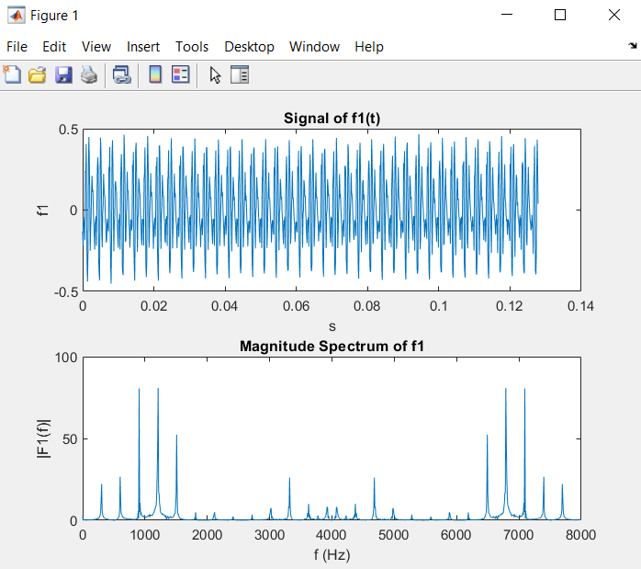
The fundamental frequency can be found in the frequency domain by finding the lowest frequency peak.
This can be done by using the findpeaks function and finding the first peak in the array. In the case of f1 the fundamental frequency is 304.7 Hz and in the case of m1 the fundamental frequency is 117.2Hz. This approximately matches what was found when the autocorrelation method was used.

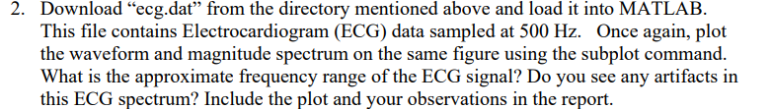
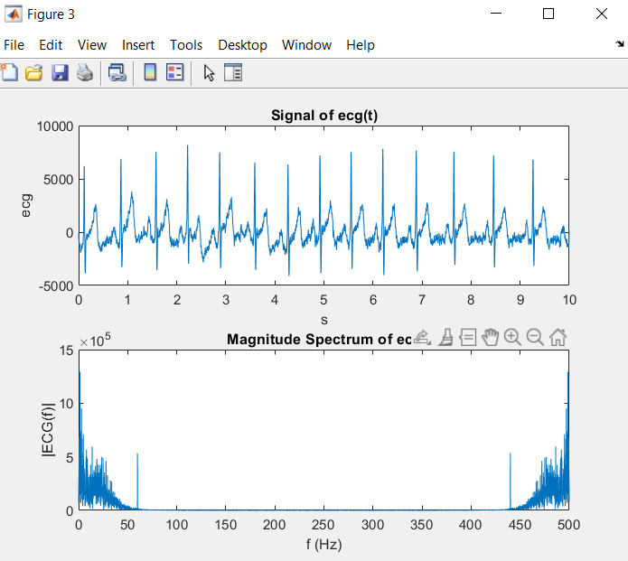
The approximate frequency range is 0-70Hz. The only artifact in the ECG spectrum is at 60 Hz, this could be because of the power system which also operates at 60 Hz.

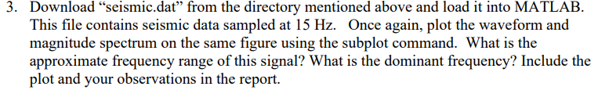
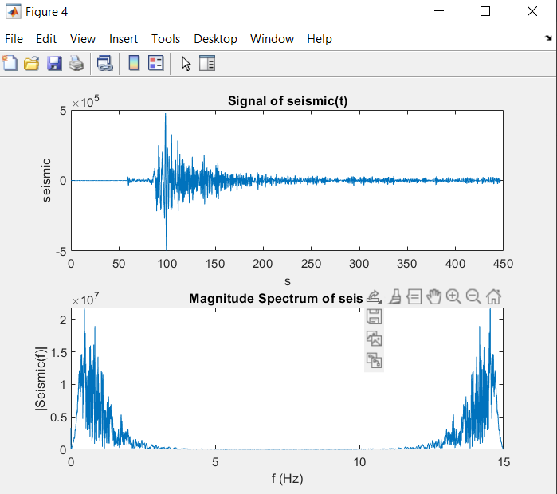
The approximate frequency range is 0-2.5kHz. . To find the dominant frequency, we find the location of the maximum magnitude in the amplitude spectrum. This location turned out to be at 0.4612 kHz.

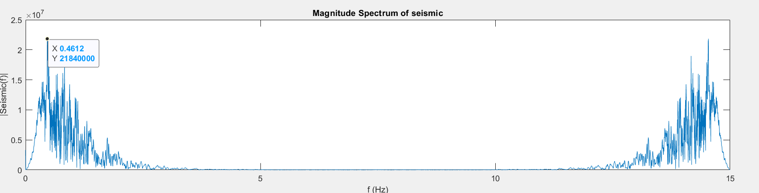

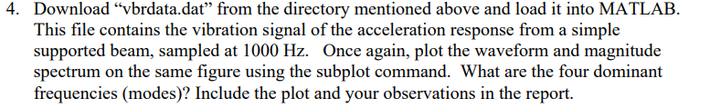
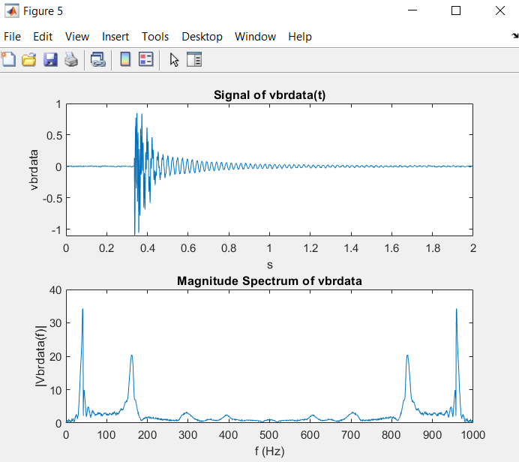
The four dominant frequencies are 41Hz, 160.5Hz, 296Hz, 395Hz.

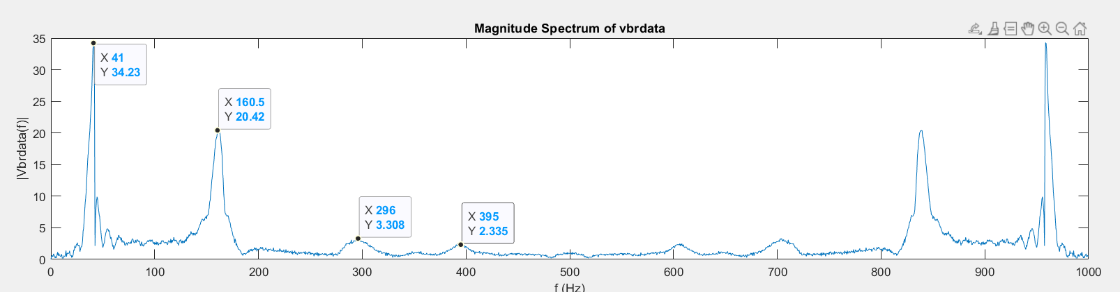

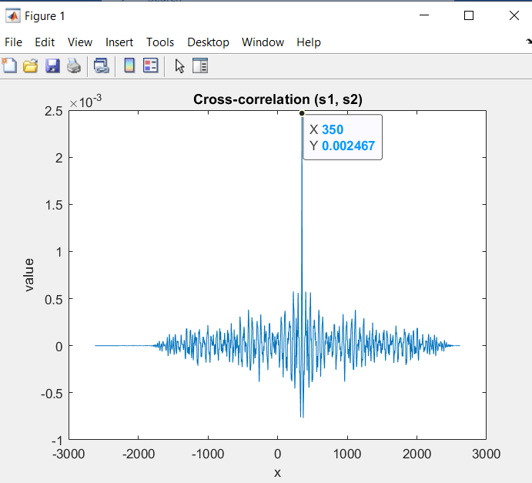
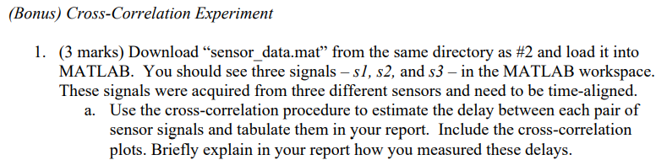
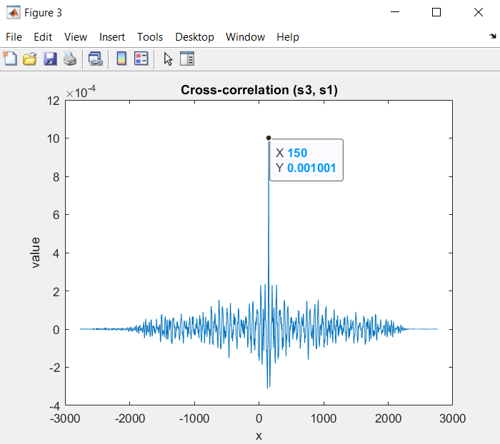
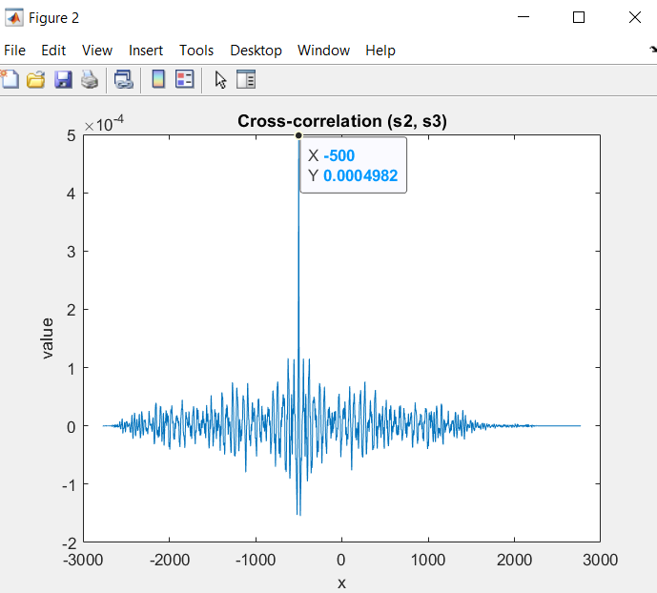
To estimate the delay between each pair of sensor signals you can find the max signal value and note the x value and then note the delay relative to other signals.

Signals compared | S1 and S2 | S2 and S3 | S1 and S3
Difference | 350 | -500 | 150

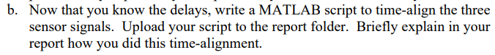

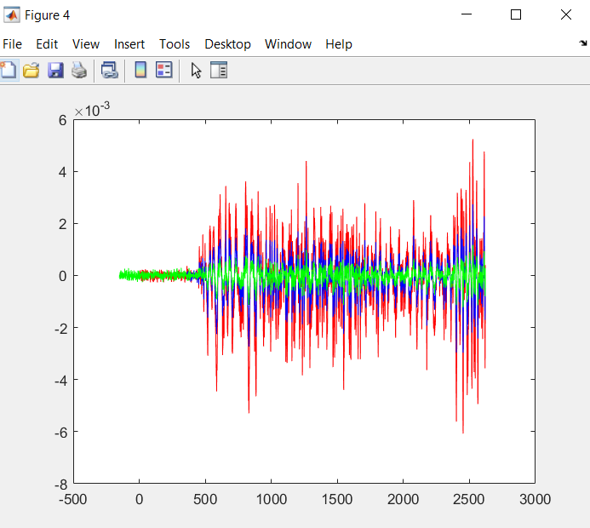
To align the signal in the time domain you must pick one signal your reference and add the differences noted in part a to the other two signals. I chose s1 as my reference and translated s2 by 350 units to the right and translated s3 by 150 units to the left.

